**Title:** GEO Database

**Date:** 9/24

**Names:**

Regina Deri, Jordan Perry-Greene, Hasham Warrich, Jun Ho Yoon

**Overview:**

This project aims to create a searchable database whereby

1. prospective study away students can search student evaluations on various factors
2. the Office of Global Education (GEO) can have both holistic and summarized view of the evaluations

**Context:**

* Amherst College students who participate in the study abroad program are required to submit an evaluation of the program.
* Currently, these evaluations are collected in Qualtrics, downloaded by GEO to an Excel file, merged with a Word doc, and then converted to PDFs that are organized by country on their website.
* For a given country, you can find a predetermined subset of questions from evaluations in the PDF for that country

**Problem:**

1. Students cannot filter evaluations or programs in their search.
2. GEO does not have an easy way to access holistic nor summarized views of the evaluations.
3. Lots of manual processing is required in reformatting the Excel file from Qualtrics and copying answers from the new file into PDFs.

**Goals:**

1. Straightforward, filterable student-side search for shared prior student evaluations
2. Admin-side search for all prior student evaluations
3. Clearer presentation of evaluations

**Design:**

* ER DIagram

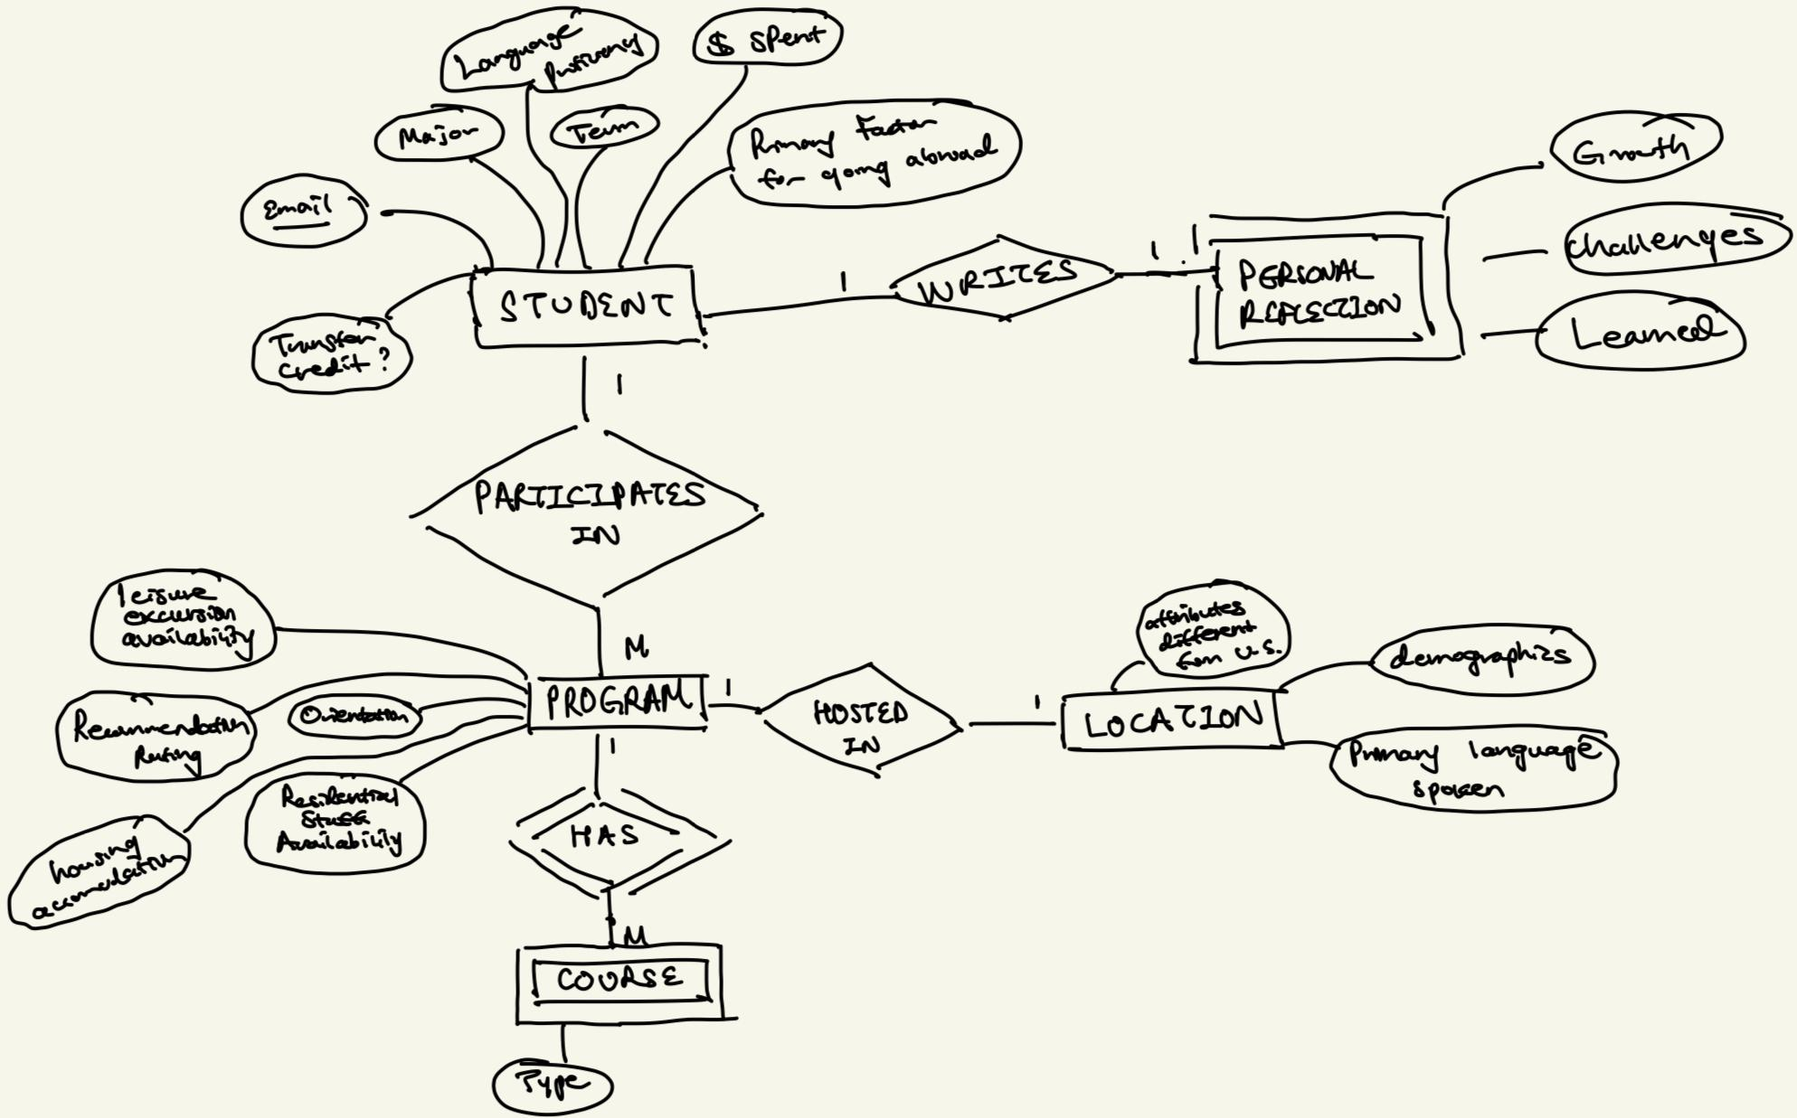

* Technology:
  + Front End: React, HTML, CSS
  + Backend: Flask, PostgreSQL
  + Processing: Pandas

**Next Steps:**

* Short Term:
  + Another meeting with the office for clarification on:
    - Functionalities
    - Security/Authentication
  + Confirm ER Diagram
* Long Term:
  + Familiarize ourselves with the tech stack:
  + ER Schema and Relational Schema (Due 10/18)
  + Determine most important information to design an elegant evaluation summary